Exploring Neighborhoods In Toronto

# Introduction

Almost a year has passed since the World Health Organization (WHO) declared Covid-19 a pandemic. Hundreds of millions of people have lived through lockdowns and city of Toronto is no different. Many of people are working from home and there is no need for them to commute. Due to this reason, there is no need for employees to be close to their office or be located close to hubs and city cores such as downtown. Covid-19 is reshaping our lives.

In this report I will be looking at the issue of housing and how the pandemic has standardized remote work, and what that might mean. Will we go to the office again – and, if so, how often? Since there is no need for people to be located close to their office and most people especially located in small apartments in downtown are deciding to move further away. Some of these employees are parents and have kids or pets. Prior to moving it will be good for these employees to look at neighborhoods that is either similar or has the necessary things they need such as school, university, trails and park, library, restaurants.

In this report I will go through step-by-step process to decide which neighborhood is a good area to move to. I will analyze the neighborhoods to identify the most or at least suitable areas to move to.

## Target Audience

Employees who are working in the downtown area which is expensive are remotely working from home. This could be:

* Parents that want to live in a neighborhood other than downtown and has almost most all the things they currently have.
* Young employees that want to live in a neighborhood other than downtown which is cheaper but at the same time has good bars and restaurants or in general night life.
* Realtors that want general information to sell a house to their clients.

# Data

## Data Sources

In this report, I will explore, segment, and cluster the neighborhoods in the city of Toronto. However, the data is not readily available on the internet. There is a Wikipedia page that has all the information we need to explore and cluster all the neighborhoods in Toronto. The link is provided “<https://en.wikipedia.org/wiki/List_of_postal_codes_of_Canada:_M>”

The above link is only for postal codes that starts with “M”. However, I will try to expand the analysis to more neighborhoods based on information from other sites such as “<http://www.geonames.org/postal-codes/CA/ON/ontario.html>”

These might not be the most updated information, but it includes most of the neighborhoods needed for this report. I will be scraping these pages and wrangle the data, clean it, and then read it into a pandas dataframe so that it is in a structured format.

I’ll be using “[https://cocl.us/Geospatial_data”](https://cocl.us/Geospatial_data%E2%80%9D) csv file to get all the geographical coordinates of the neighborhoods for the postal codes that start with “M” and extract the postal codes from the rest of the neighborhoods from “<http://www.geonames.org/postal-codes/CA/ON/ontario.html>”.

To get information about venues in different neighborhoods Foursquare’s explore API will be used. This API will retrieve information and details such as name, category, latitude, and longitude for different neighborhoods.

## Data Wrangle & Cleaning

Scraped the following Wikipedia page, “*List of Postal code of Canada: M*” that was mentioned in the previous section in order to obtain the data about the Toronto and the neighborhoods in it. The Dataframe will consist of three columns: PostalCode, Borough, and Neighborhood. Only the cells that have an assigned borough will be processed and Boroughs that is not assigned are ignored. More than one neighborhood can exist in one postal code area. For example, in the table on the Wikipedia page, you will notice that M5A is listed twice and has two neighborhoods: Harbourfront and Regent Park. These two rows will be combined into one row with the neighborhoods separated with a comma. as shown in row 11 in the above table. If a cell has a borough but a Not assigned neighborhood, then the neighborhood will be the same as the borough.

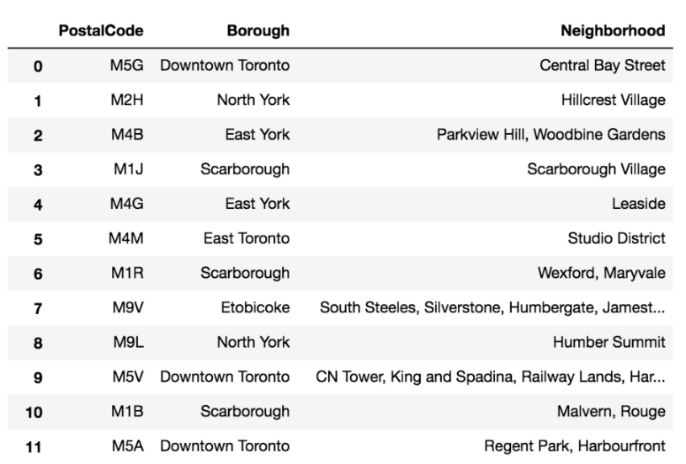

Pandas Module was used to import the table. Sample of the result can be seem in the table below:

# Webpage url

url = 'https://en.wikipedia.org/wiki/List_of_postal_codes_of_Canada:_M'

# Extract tables

dfs = pd.read_html(url)

# Get first table

df = dfs[0]

print(df)

print(df.columns)

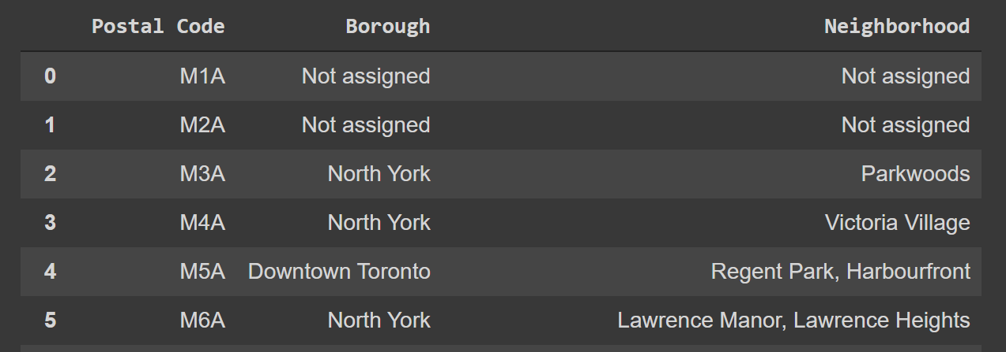

The dataframe was wrangled in the order of Postal code, Borough and Neighborhood.

#Only process the cells that have an assigned borough. Ignore cells with a borough that is Not assigned

df2=df[df["Borough"]!="Not assigned"]

df2.reset_index(drop=True,inplace=True)

print(df2)

df=df.rename(columns={"Neighbourhood": "Neighborhood"})

for i,row in enumerate(df2["Neighborhood"]):

  if row=="Not assigned":

    df2[i,"Neighborhood"]=df2[i,"Borough"]

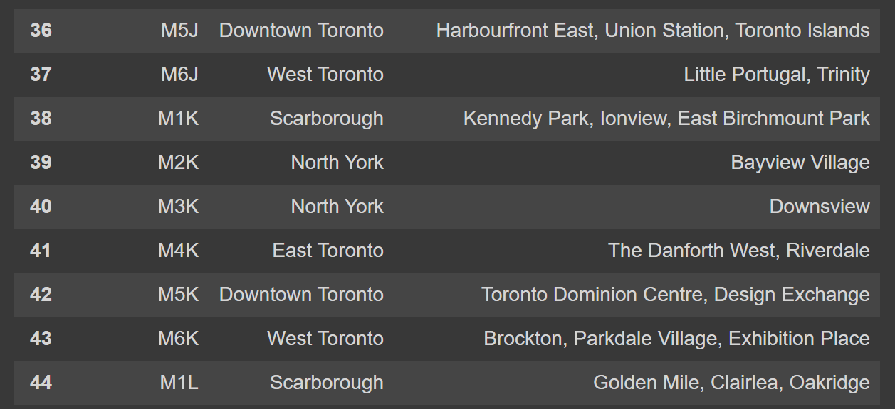

Once the above format was achieved the latitude and longitude was added to these neighborhoods. These information was added by merging with the “[http://cocl.us/Geospatial_data](https://cocl.us/Geospatial_data)” and I’m combining it with the existing neighborhood dataframe by merging them both based on the postal code.

import geocoder # import geocoder

url_coords='https://cocl.us/Geospatial_data'

df_coords=pd.read_csv(url_coords)

df_with_coord=pd.merge(df2,df_coords,how='inner',on='Postal Code')

df_with_coord.head()

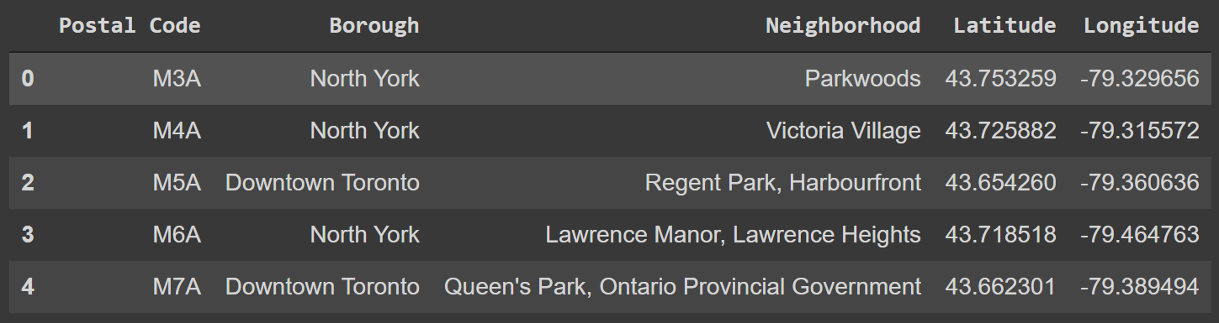

The information of this website <http://www.geonames.org/postal-codes/CA/ON/ontario.html> was also used and formatted into the same format as the above dataframe. The initial table from the website looks like below:

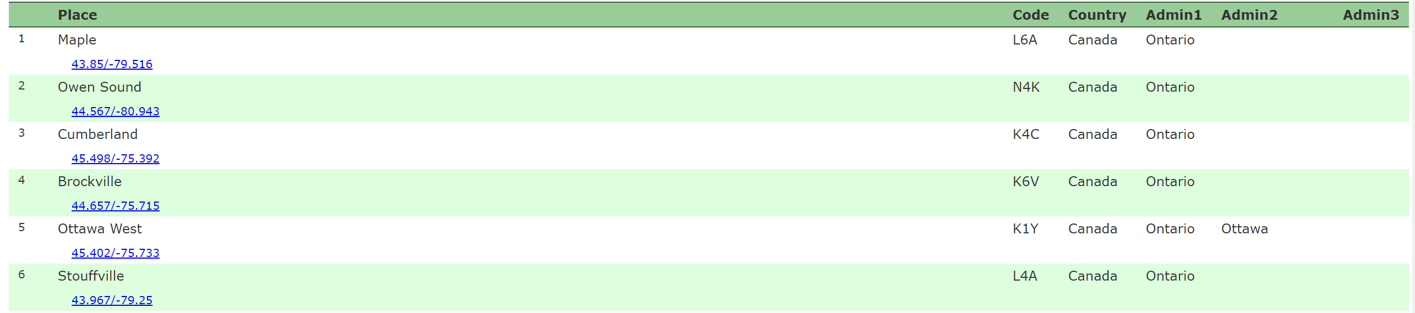

After cleaning up the above data first in Excel by converting it into the proper table form by removing the coordinates to from below the Place column to their own column Latitude and Longitude and removing the Country column and then doing the same process as we did to the Wikipedia information. This tables were appended to the Wikipedia information that has the coordinates. Our final dataframe is now ready for next procedure. A Sample of the above cleaned information can be seen below.

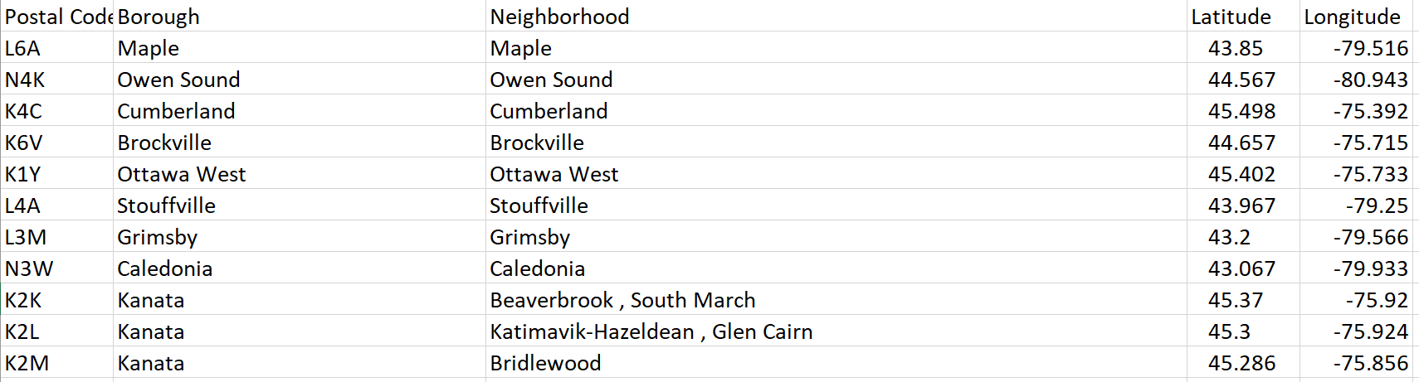

Foursquare was used by creating a function to explore all the neighborhoods by going over the latitudes and longitudes and sending a GET Request.

# function that extracts the category of the venue

def get_category_type(row):

    try:

        categories_list = row['categories']

    except:

        categories_list = row['venue.categories']

    if len(categories_list) == 0:

        return None

    else:

        return categories_list[0]['name']

The JSON information is now ready to be cleaned and structured into a pandas dataframe.

venues = results['response']['groups'][0]['items']

nearby_venues = json_normalize(venues) # flatten JSON

# filter columns

filtered_columns = ['venue.name', 'venue.categories', 'venue.location.lat', 'venue.location.lng']

nearby_venues =nearby_venues.loc[:, filtered_columns]

# filter the category for each row

nearby_venues['venue.categories'] = nearby_venues.apply(get_category_type, axis=1)

# clean columns

nearby_venues.columns = [col.split(".")[-1] for col in nearby_venues.columns]

nearby_venues.head()

The information will look like the table below:

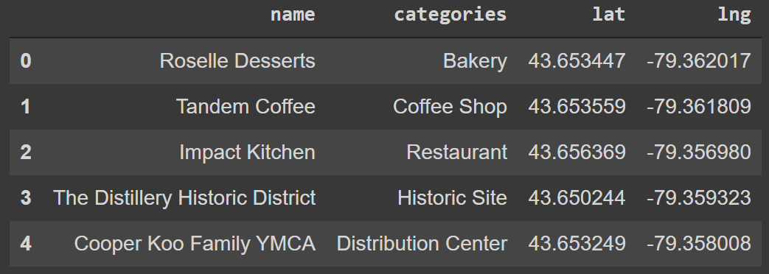

# Methodology

As mentioned in the previous section we imported the initial data from Wikipedia. Once we did the data cleaning and preparation the additional information will be added using the Pandas Library.

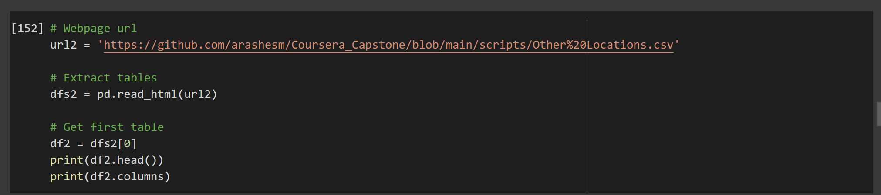

The head and tail result will be as shown below:

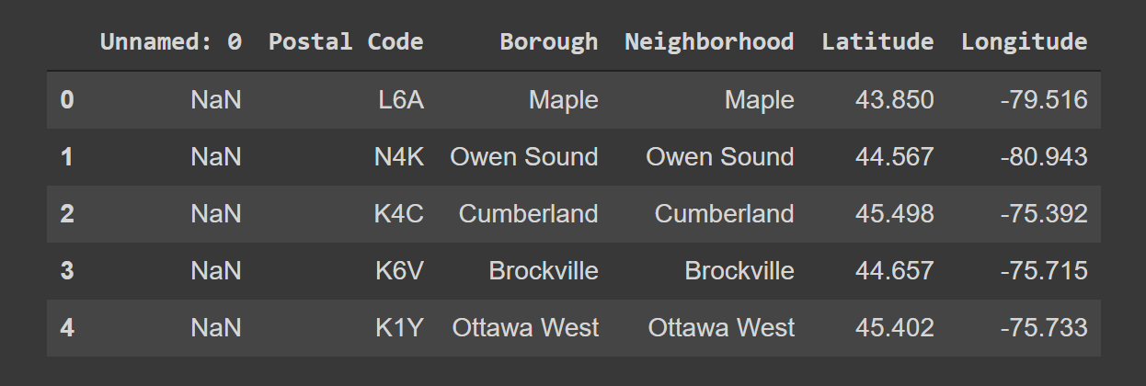

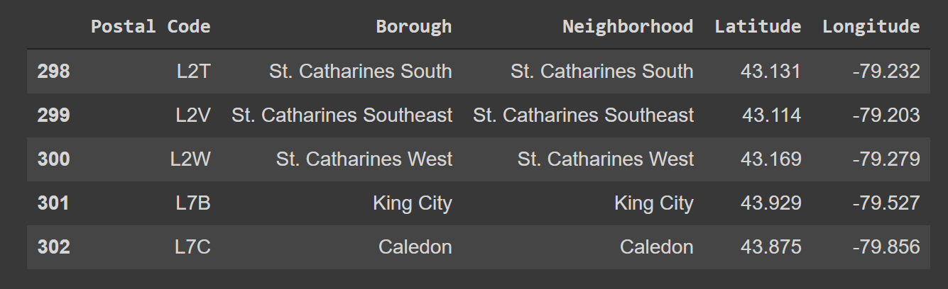

This information is added to the Wikipedia dataframe.



Once the data is ready, Folium is the python library that will be used in this report to plot the locations as seen in the picture below. The map below shows the result prior to the clustering.

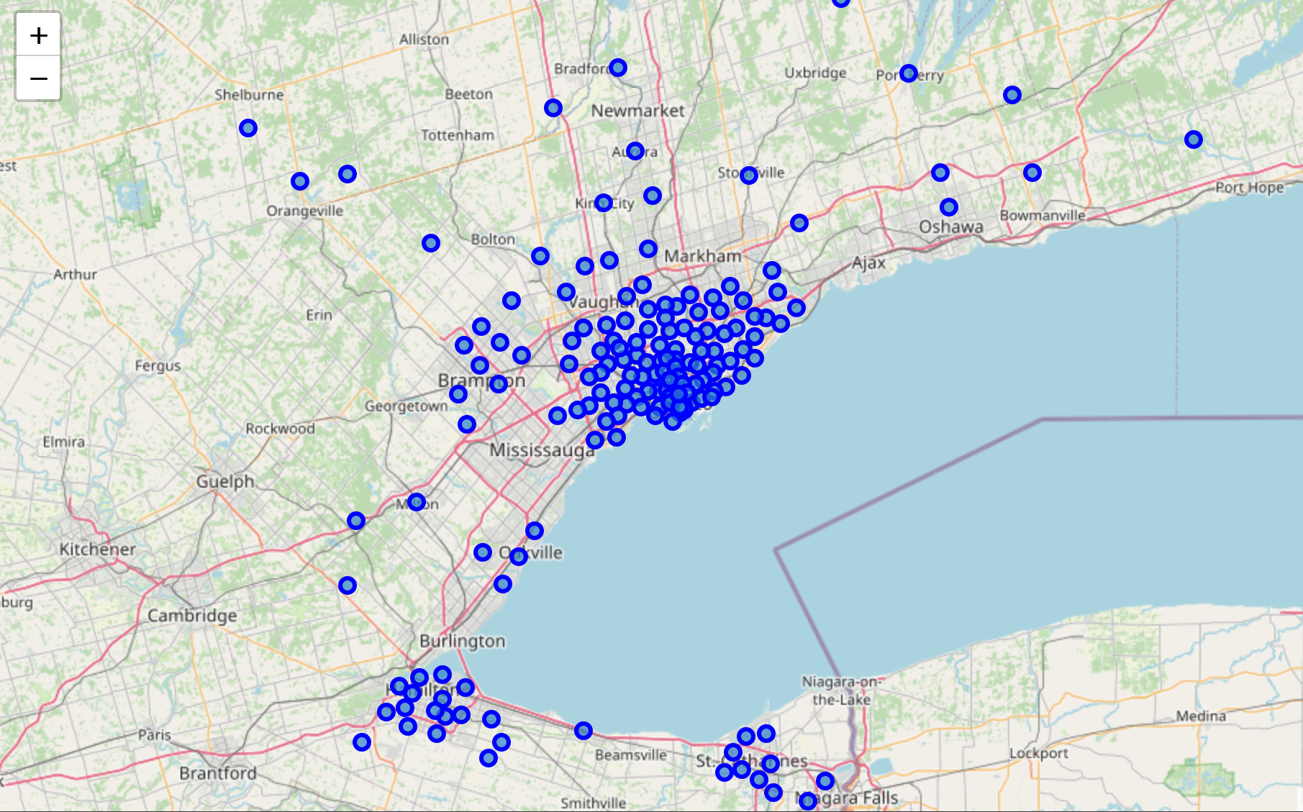

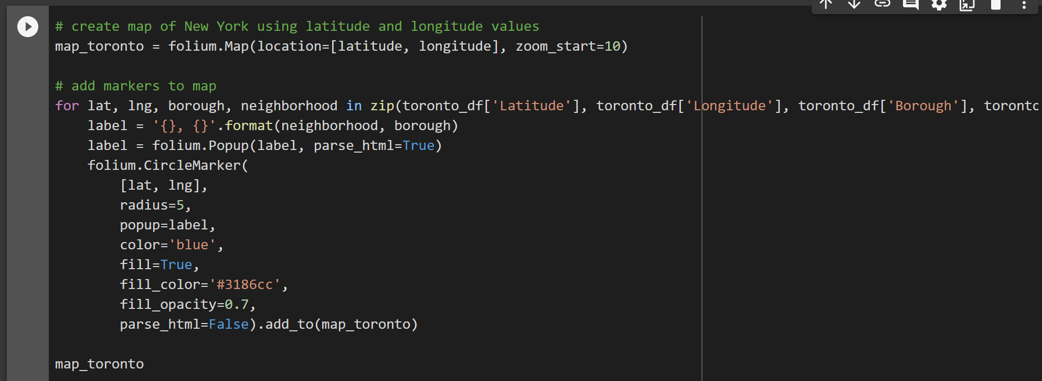

For the Machine Learning Method, K-means clustering was used. 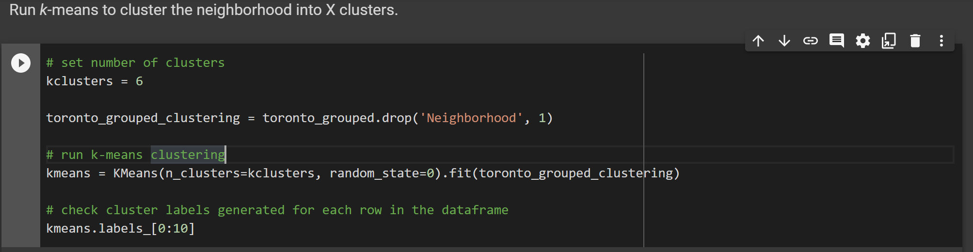

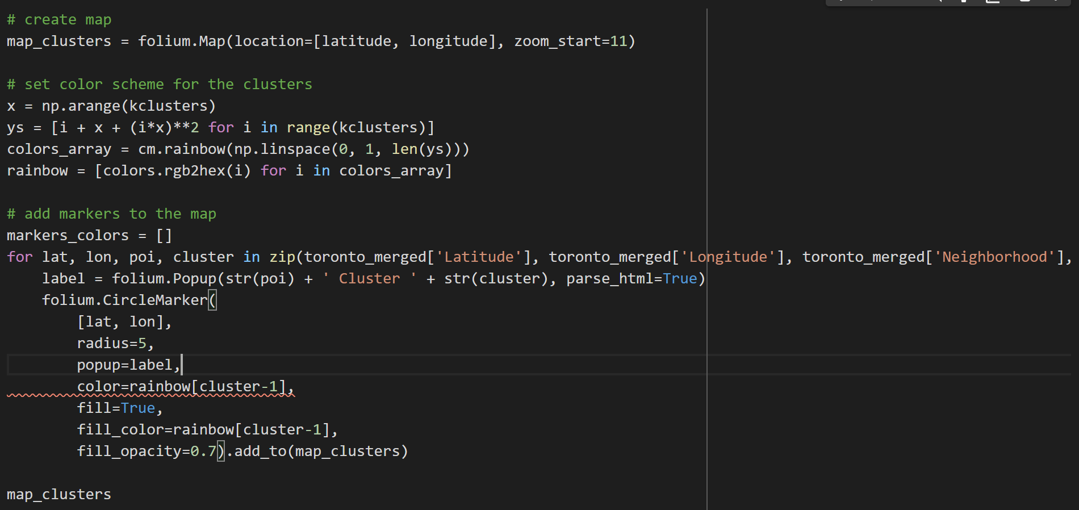

# Result

The result of the analysis can be seen in the below picture. Also a wider zoom image has been provided as well for more neighborhoods.

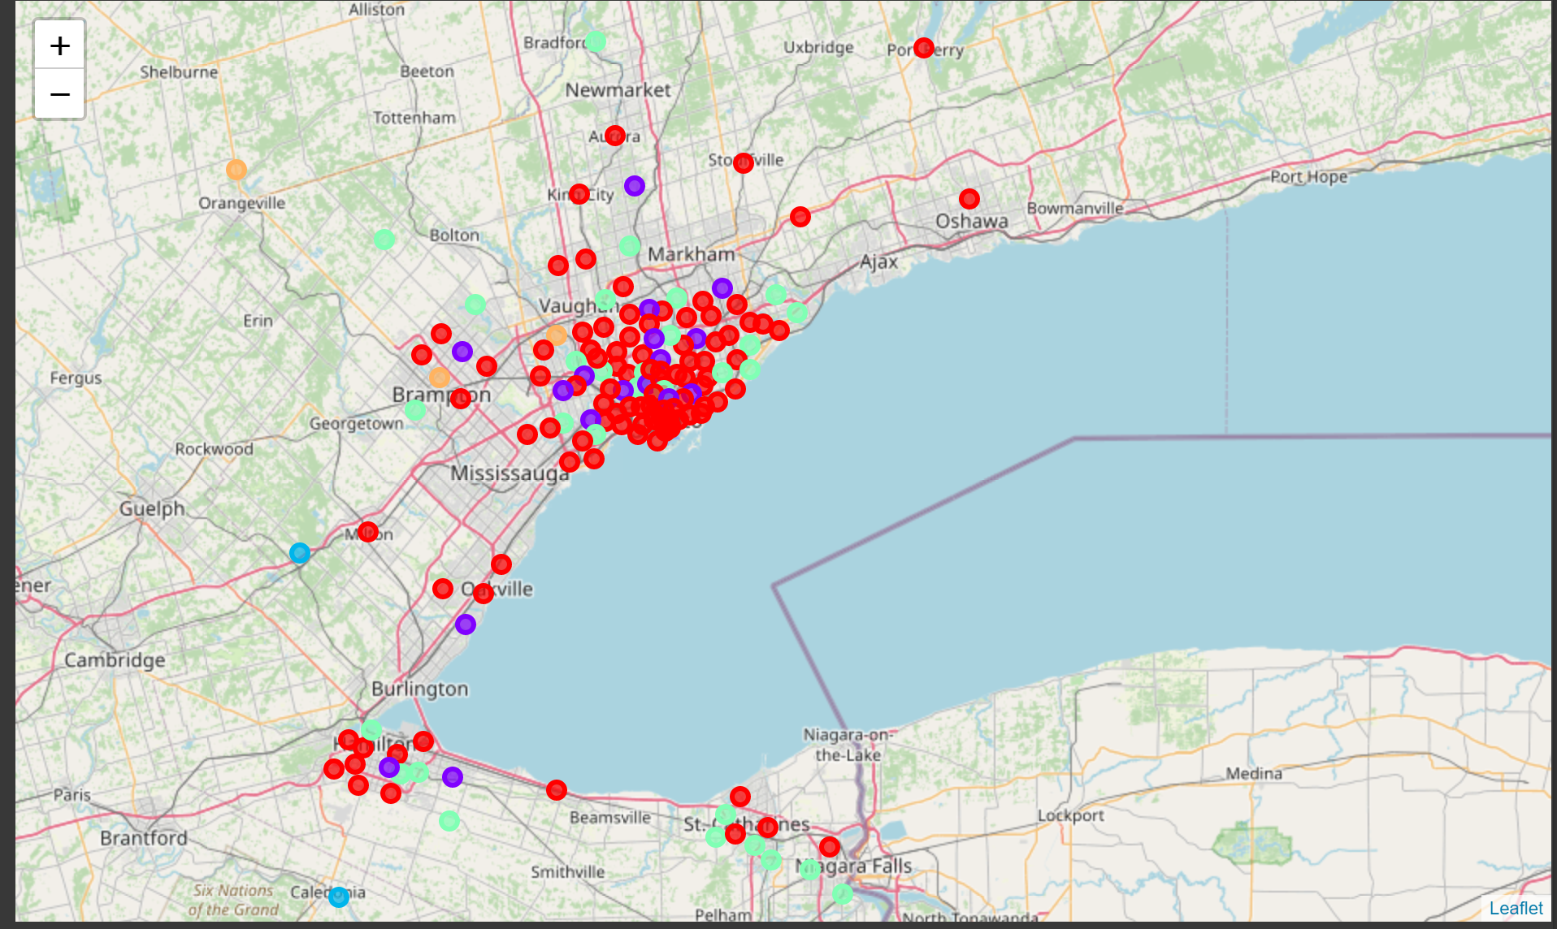

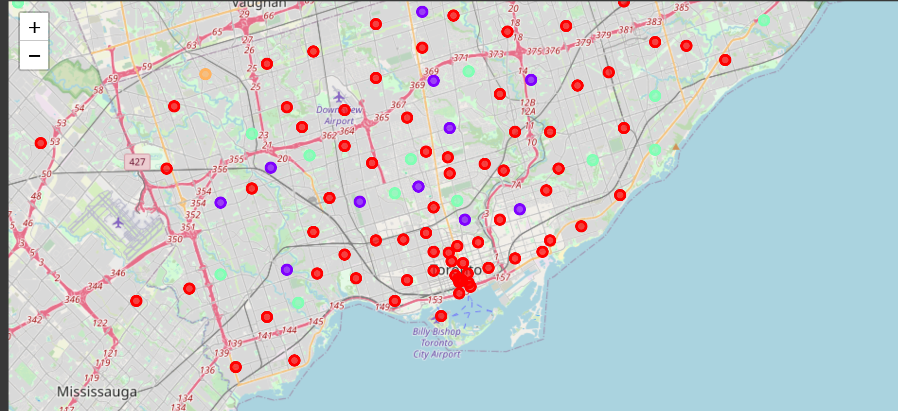

* Clusters is red represents restaurants and coffee shops.
* Clusters is purple represents park and playgrounds with some restaurants.
* Clusters is blue represents trail and camps.
* Clusters is green represents sport courts and restaurants.
* Clusters is orange represents construction and landscaping.

As it can been by the map people are moving out towards Orangeville since construction is happening there a lot it is also cheaper. Neighborhoods such as Etobicoke are good since they have red color for restaurants and coffee shops for adults which downtown as but as a plus it has green color as well which is good for families since it has sport courts.

Areas such as Brampton has a lot to offer as well since it has few colors in it. Over all this analysis can be used for people to see what’s a good alternative to Toronto for them

# Discussion

According to this analysis, downtown Toronto or to be more specific city of Toronto is not the only location that has everything for employees living there. At some point it was convenient for them since it was close to their offices. However, after the pandemic things have changed. North York, Richmond Hill, and Markham also even newer less populated communities such as New Market and Arura could compete with Toronto due to cheaper houses considering if people are going to work remotely. Some of these neighborhoods are highlighted below.

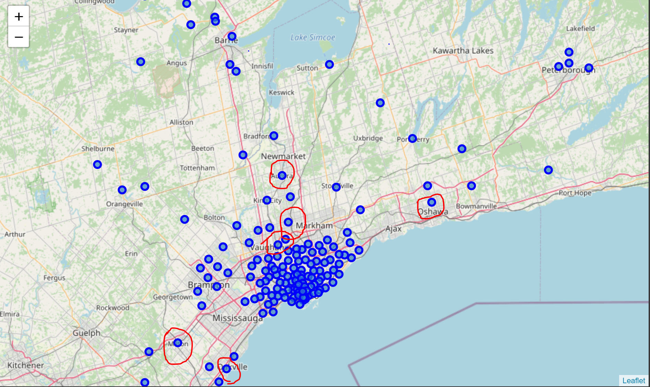

As it can be seen in the above map some neighborhoods such as Newmarket, Scarborough, Markham, Oakville borough will provide less competition in terms of price and house sizes for people moving in. Also, other factors are important that has not been included in this analysis. In this analysis the clustering is completely based only on data obtained from Foursquare which is more related to exploring neighborhoods in terms of what is around it. Factors such as population, ethnicity safety are not included in this analysis. For example, the table below from <https://www.getwhatyouwant.ca/> shows the price of properties in 2019 in different regions. This analysis is showing that if other neighborhoods have almost the same characteristics in terms of venues why not move out to other regions.

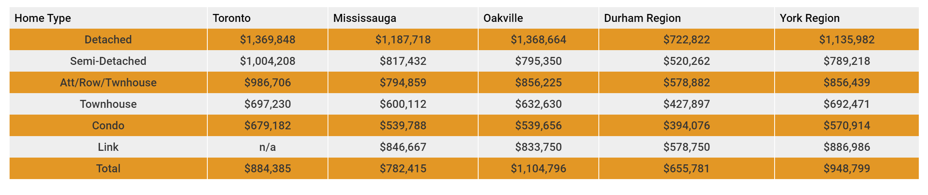

There are lots of areas where it can be improved to get a more precise result but this analysis and report has given us some good intuitions.

# Conclusion

Python libraries were used to get the data from Wikipedia and Geonames. The data was then manipulated. Afterwards Foursquare API was used to explore the venues in neighborhoods of Toronto. Machine Learning Clustering technique was used to predict the output and Folium was used to visualize the data with the proper cluster color on a map.

Overall analysis shows that the results can be improved if more time, data, and knowledge is put into it. However, we can use this project to analysis any scenario such as moving to a new neighborhood and comparing it to the current residing neighborhood. Such as the current pandemic scenario that people are moving out of town or to the suburbs. As a result it is observed that in Toronto people are leaving and the number of vacant condos are more than anytime before.